Project Design Phase - II Data Flow Diagram & User Stories

|  |  |
| --- | --- |
| Date | 11 October 2022 |
| Team ID | PNT2022TMID19800 |
| Project Name | SMARTFARMER – IOT ENABLED SMART FARMING APPLICATION |
| Maximum Marks | 4 Marks |

# Data Flow Diagrams:

A Data Flow Diagram (DFD) is a traditional visual representation of the information flows within a system. A neat and clear DFD can depict the right amount of the system requirement graphically. It shows how data enters and leaves the system, what changes the information, and where data is stored.

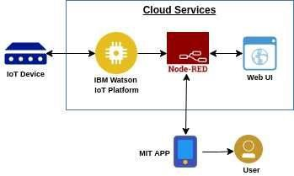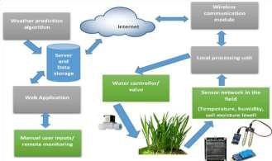

* The different soil parameters temperature, soil moistures and then humidity are sensed using different sensors and obtained value is stored in the IBM cloud.
* Arduino UNO is used as a processing Unit that process the data obtained from the sensors and whether data from the weather API.
* NODE-RED is used as a programming tool to write the hardware, software, and APIs. The MQTT protocol is followed for the communication.
* All the collected data are provided to the user through a mobile application that was developed using the MIT app inventor.
* The user could plan through an app, weather to water the crop or not depending upon the sensor values. By using the app, they can remotely operate to the motor switch.

# User Stories:

|  |  |  |  |  |  |  |
| --- | --- | --- | --- | --- | --- | --- |
| **User Type** | **Functional Requirement** | **User Story Number** | **User Story/Task** | **Acceptance criteria** | **Priority** | **Release** |
| Customer (Mobile user) | Registration | USN-1 | As a user, I can register for the application by entering my  email, password and confirming my password. | I can access my account/ dashboard | High | Sprint-1 |
|  | Permission | USN-2 | As a user, I will receive confirmation email once I have registered for the application. | I can receive confirmation email & click  confirm. | High | Sprint-1 |
| Customer (Web user) | Login | USN-3 | As a user, I can log into the application by entering email & password. | I can register & access  the dashboard with Login | High | Sprint-2 |
|  | Check credentials | USN-4 | As a user, I can register for the application through mobile application | Temperature and  Humidity details | Medium | Sprint-1 |
|  | Dashboard | USN-5 | As a user can view the dashboard and this dashboard include the check roles of access and then move to the manage modules. | I can view the dashboard in this smart farming application system. | Medium | Sprint-1 |
| Customer care Executive | MIT app | USN-6 | To make the user to interact with the software. | Database to store in cloud services. | High | Sprint-1 |
| Administrator | IOT devices | USN-7 | As a user once view the manage modules this describes the manage system admins and Manage Roles of user and etc.., |  | Medium | Sprint-1 |
|  | Log out | USN-8 | Exit | Sign out | High | Sprint-1 |